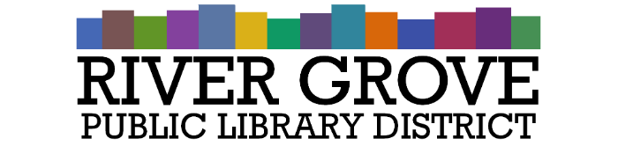**River Grove Public Library District**

8638 W Grand Ave

River Grove, IL 60171

708.453.4484

**Board Meeting Agenda**

**Date: 5/14/2025**

**Time: 6:00pm**

**Place: Library – Youth Room**

1. **CALL TO ORDER**
2. **GUESTS**

a. James Rachlin, Meristem Advisors

1. **APPROVAL OF MINUTES**

a. Regular Meeting 4/9/2025

1. **CORRESPONDENCE**
2. **TREASURER’S REPORT**
3. **BILLS FOR APPROVAL**
4. **PRESIDENT’S REPORT**
5. **DIRECTOR’S REPORT**
6. **COMMITTEE REPORTS**
7. **BUILDING AND GROUNDS**
8. **OLD BUSINESS**
9. **NEW BUSINESS**

a. ACTION: Swearing in of new trustees

b. DISCUSSION: Library Working Budget FY 25-26

c. ACTION: Library closing during River Fest 5/29-3/31

d. ACTION: Engagement letter from GW & Associates

e. ACTION: Adoption of Builder’s Risk policy from Utica

1. **PUBLIC COMMENTS**
2. **EXECUTIVE SESSION**
3. **ADJOURNMENT**