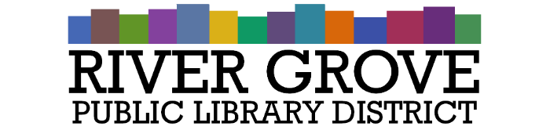**River Grove Public Library District**

8638 W Grand Ave

River Grove, IL 60171

708.453.4484

**Board Meeting Agenda**

**Date: 7/9/2025**

**Time: 6:00pm**

**Place: Library – Youth Room**

1. **CALL TO ORDER**
2. **GUESTS**
3. **APPROVAL OF MINUTES**

a. Regular Meeting 6/11/2025

1. **CORRESPONDENCE**

a. Office of the Attorney General, State of Illinois RE: OMA Requests for Review – 2019 PAC 57195, 2019 PAC 57267

1. **TREASURER’S REPORT**
2. **BILLS FOR APPROVAL**
3. **PRESIDENT’S REPORT**
4. **DIRECTOR’S REPORT**
5. **COMMITTEE REPORTS**
6. **OLD BUSINESS**
7. **NEW BUSINESS**

**a. ACTION:** Swearing in of new trustees

**b. ACTION:** Approval of board meeting dates for FY 25-26

**c. ACTION:** Set hearing date for Budget and Appropriation ordinance for **August 13, 2026 at 5:30**

**d. ACTION:** An Ordinance of the River Grove Public Library District, Cook County, Illinois, authorizing and providing for an Installment Purchase Agreement for the purpose paying the cost of purchasing real or personal property, or both, in and for the District, and authorizing and providing for the issue of the District’s Debt Certificate, Series 2025 in an aggregate principal amount not to exceed $750,000, evidencing the rights to payment under the Agreement, prescribing the details of the Agreement and Certificate, and providing for the security for and means of payment under the Agreement of the Certificate.

**e. ACTION:** Adopt standard per diem ME&I total for 2025 of $68 per day for continuing education events that require travel

1. **PUBLIC COMMENTS**
2. **EXECUTIVE SESSION**
3. **ADJOURNMENT**