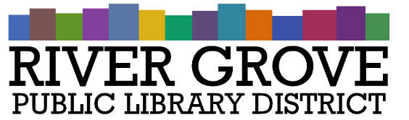
River Grove Public Library District
8638 W Grand Ave
River Grove, IL 60171
708.453.4484

Board Meeting Agenda
Date: 12/14/2022
Time: 6:00pm
Place: Library – Youth Room

- CALL TO ORDER

- GUESTS

- APPROVAL OF MINUTES
  - Regular Meeting Minutes – November 9th, 2022 (ACTION ITEM)
  - Executive Session Minutes – November 9th, 2022 (ACTION ITEM)
  - Special Meeting Minutes – November 21, 2022 (ACTION ITEM)
  - Special Meeting Minutes – December 5, 2022 (ACTION ITEM)

- CORRESPONDENCE
  - Cook County Clerk: 2021 Agency Tax Rate Report

- TREASURER’S REPORT
  - Approval of November 2022 Treasurer’s Report (ACTION ITEM)

- BILLS FOR APPROVAL
  - Approval of Bills presented in December 2022 (ACTION ITEM)

- PRESIDENT’S REPORT

- DIRECTOR’S REPORT
  - State of the library
  - Library statistics

- COMMITTEE REPORTS

- BUILDINGS AND GROUNDS

- OLD BUSINESS

- NEW BUSINESS
a. Meeting Dates 2023 (ACTION ITEM)
- Library Closures 2023 (ACTION ITEM)
- Staff In-Service Day (ACTION ITEM)
- Year-End Staff Review (ACTION ITEM)

- PUBLIC COMMENTS

- EXECUTIVE SESSION
a. The Board of Library Trustees will meet in Executive Session under the exception of the Open Meetings Act ILCS Chapter 5, Act 120/2 (c) Exceptions: “The purchase or lease of real property for the use of the public body, including meetings held for the purpose of discussing whether a particular parcel should be acquired.”
- ADJOURNMENT

